### Hardware Display:

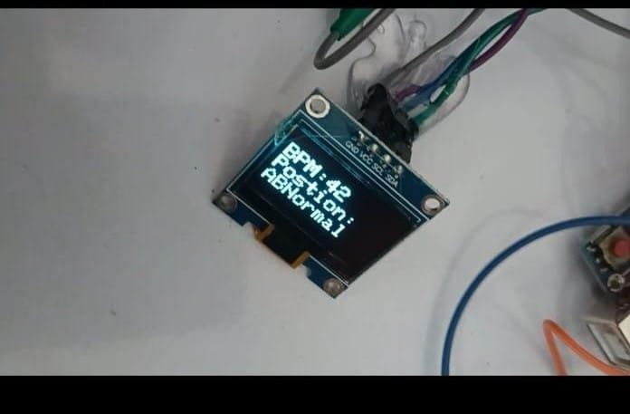

Figure 5.1 Hardware Display

### Output:

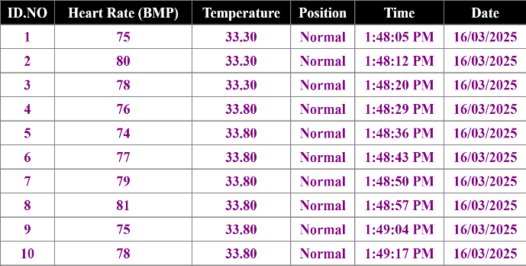

Table 5.1 Recorded Physiological Data for Normal person

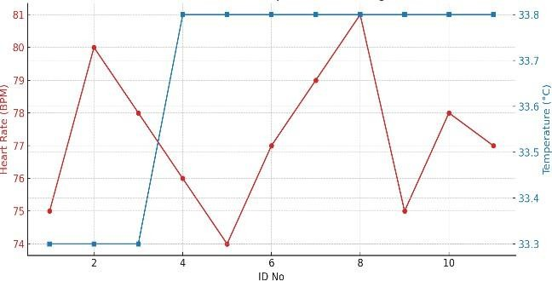

Heart Rate (Between 50 BPM and 115 BPM) and Temperature Analysis Over Time

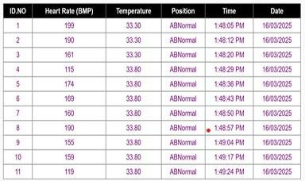

Table 5.2 Recorded Physiological Data for Parkinson’s Disease Identification

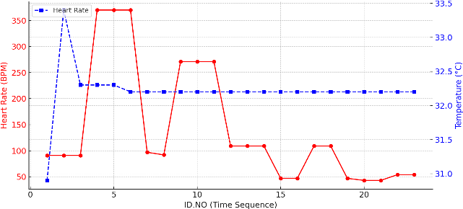

Heart Rate above 115(BMP) and Temperature Analysis Over Time